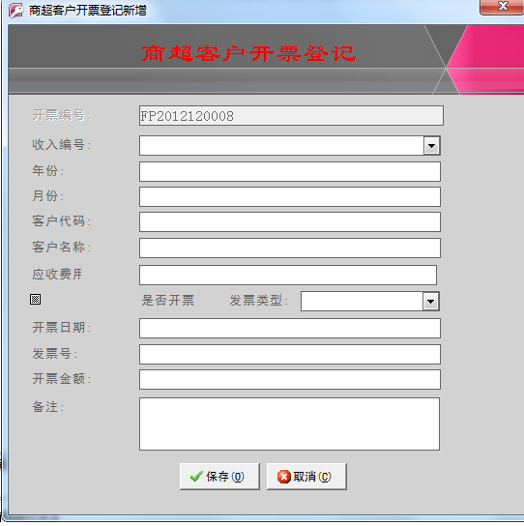

发票新增窗体中，通过建立同收入编号一对一的关系，在保存后不但将数据保存在开票明细表中，而且将相关的开票信息也传递保存到收入的明细表中相对应的表中。

**附表为收入明细表**

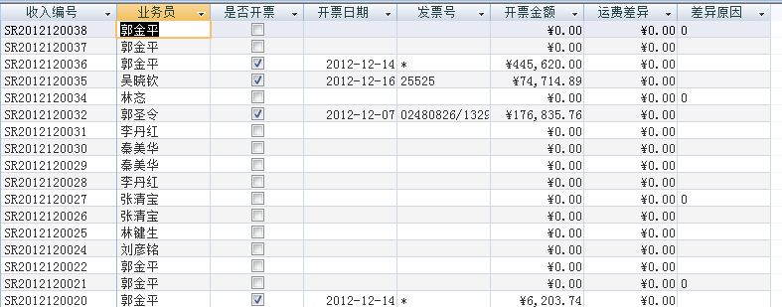

代码如下：

Private Sub cmd_Save()

Dim i As Integer

Dim stemp As String

Dim rst As adodb.Recordset

Set rst = New adodb.Recordset

Dim rst1 As adodb.Recordset

Set rst1 = New adodb.Recordset

If IsNull(Me.fplx) Then

MsgBox "请输入发票类型!", vbCritical, "提示："

Me.fplx.SetFocus

Exit Sub

End If

If IsNull(Me.开票日期) Then

MsgBox "请输入开票日期!", vbCritical, "提示："

Me.开票日期.SetFocus

Exit Sub

End If

If IsNull(Me.发票号) Then

MsgBox "请输入发票号!", vbCritical, "提示："

Me.发票号.SetFocus

Exit Sub

End If

If IsNull(Me.开票金额) Then

MsgBox "请输入开票金额!", vbCritical, "提示："

Me.开票金额.SetFocus

Exit Sub

End If

Me.Refresh

If MsgBox("您确认要保存吗?", vbOKCancel + vbInformation, "提示") = vbOK Then

stemp = "select * from tblkhkpmx"

rst.Open stemp, CurrentProject.Connection, adOpenKeyset, adLockOptimistic

rst.AddNew

rst("kpid") = Me.kpid

rst("srid") = Me.收入编号

rst("khid") = Me.客户编号

rst("khmc") = Me.客户名称

rst("nf") = Me.年份

rst("yf") = Me.月份

rst("sfkp") = True

rst("kprq") = Me.开票日期

rst("kpje") = Me.开票金额

rst("fph") = Me.发票号

rst.Update

rst.Close

Set rst = Nothing

'刷新数据

If IsLoaded("usysfrmMain") Then

DoCmd.Echo False

Forms!usysfrmmain!frmChild.SourceObject = "frmkhkpmx_child"

DoCmd.Echo True

红色加粗的代码为加入到收入明细表中的代码

End If

**stemp = "Select * From tblscsr"**

**rst1.Open stemp, CurrentProject.Connection, adOpenKeyset, adLockOptimistic**

**rst1.MoveFirst**

**For i = 1 To rst1.RecordCount**

**If rst1("srid") = Me![收入编号] Then**

**rst1("sfkp") = True**

**rst1("kprq") = Me.开票日期**

**rst1("kpje") = Me.开票金额**

**rst1("fph") = Me.发票号**

**rst1.Update**

**Exit For**

**Else**

**rst1.MoveNext**

**End If**

**Next i**

**Set rst1 = Nothing**

MsgBox "保存成功!", vbInformation, "提示"

Me.收入编号 = Null

Me.年份 = Null

Me.月份 = Null

Me.客户编号 = Null

Me.客户名称 = Null

Me.开票日期 = Null

Me.开票金额 = Null

Me.发票号 = Null

Me.fysum = Null

Me.bz = Null

Me.fplx = Null

End If

DoCmd.Close acForm, Me.Name

End Sub

要求：我想删除发票明细后，收入发票的相关信息恢复到最初未开票的状态。如何做

代码是否在删除的代码中写，我试着写了一段，但是会溢出，好像有问题，希望老师给予指点。

